E-Project
Web Designing
PRIME-FITNESS

Author | Aptech – C1908I3 – Group 4
Author | - PHAT VU MINH – Student1219696 (Leader)  - ANH TRAN HOANG – Student1219210  - DUC HO NGOC – Student1219661
Centre Name | Aprotrain Aptech
Date | 27th, June 2020
Semester | 1
Instructor | NGUYEN TRUONG NGOC KHAC

HCM City, 27th June 2020

CHAPTER I: PROBLEM DEFINITION
Introduction and Existing Scenario:

Prime Fitness is fitness club established in the year 1982. The fitness club has equipped with all basic fitness equipment and also included the newly introduced. The Prime fitness club is the flagship brand for Prime Fitness Club Ltd, a UN based health and fitness services provider and a pioneer in the “Integrated Health Club Management Solutions’ business. Prime Fitness Club ltd focuses on staying fit is most important to meet the challenging requirements.
The website is to be developed for the Windows Platform using HTML5, JavaScript and Geolocation. The site should work well in all leading browsers including Chrome, IE, Firefox etc.

CHAPTER II: REQUIREMENT SPECIFICATION

The Web site is to be created based on the following requirements.

- Home page should be designed with the appropriate template and navigational link.
- Designing and navigation both must be made user friendly.
- Links can be:
  - Cycling
  - Swimming
  - Sports & Fitness
  - Group Exercise
  - Membership
  - Salon & Spa
  - Gallery
  - List of equipments with its description.
- About us. There should be a “Contact Us” page which will have the Address of the Company which should be displayed using GeoLocation API (eg. GoogleMaps) and the email address which when clicked will invoke the local mail client from where they can send an email.
- FAQ’s
- Enquiry Form
- Site Map

Technical System Requirements
Hardware:
- A minimum computer system that will help you access all the tools in the courses is a Pentium 166 or better
- 64 Megabytes of RAM or better
Software:
- Visual Studio Code: 1.46.1 (user setup)
- Wampsever: version 7.3.12
- Windows 10
CHAPTER III: ARCHITECTURE AND DESIGN PROJECT
Tiers of Application:
- Design project by DFD/UML:
- Define DFD
Data Flows Diagram (DFD) describes the information flow in the
system. The next step of system analysis is to consider in detail the
information necessary for the implementation for functions discussed
above and the one necessary for the improvement of the functions.
Modeling tool frequently used for this purpose is DFD. DFD will support 4 main activities.
- Analysis
DFD is used to determine requirement of users.
- Design
DFD is used to map out plan and illustrate solution to analysis and
users while designing a new system.
- Communication
One of the strength of DFD is its simplicity and ease to understand
to analysts and users.
- Document
DFD is used to provide special description of requirement and
system design. DFD provide an overview of key functional components of the system but it does not provide any detail on these components. We have to use other tools like database dictionary, process specification to get and idea of which information will be exchanged and how.
- The main Component of Context Diagram

- DFD Analysis: Design main functions of system
Lv.0

Lv.1: Login and Register Account

Lv.1: Create/update information about User/Product

- Database Structure Design for eProject:

Chapter IV: Interface Snapshot:
Homepage:

Register:

Login:

Blog List:

Product Detail:
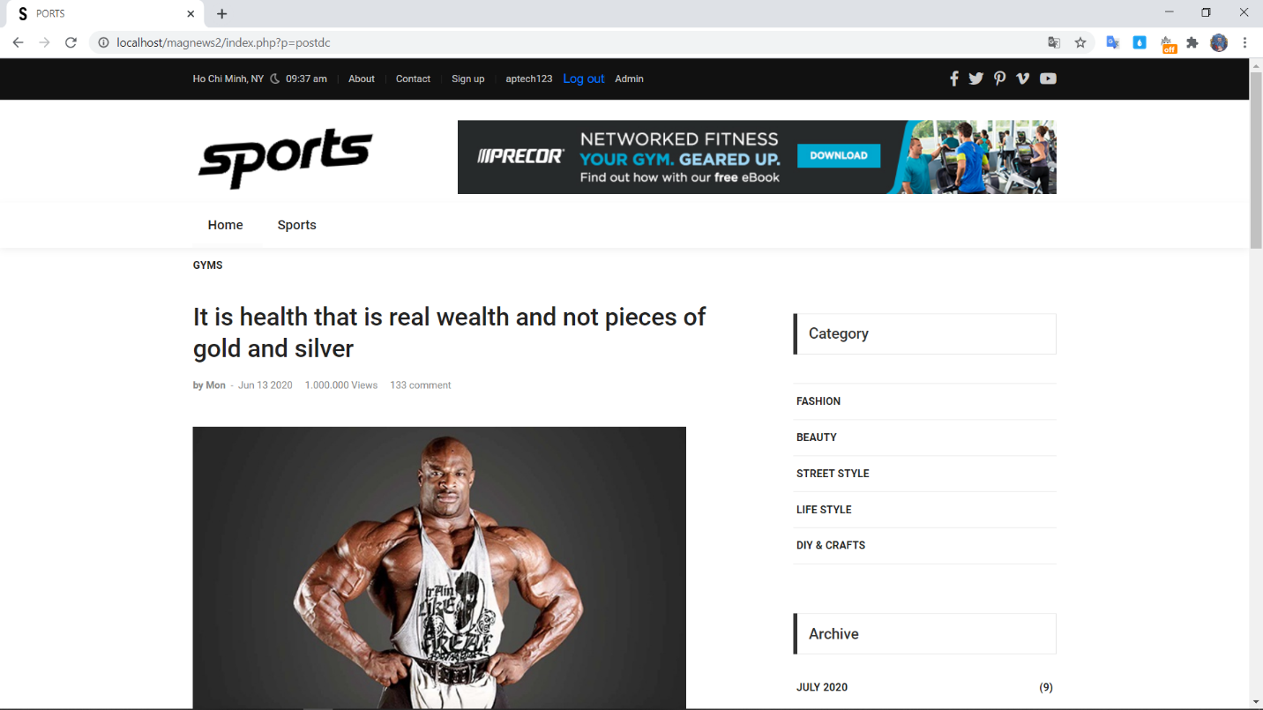
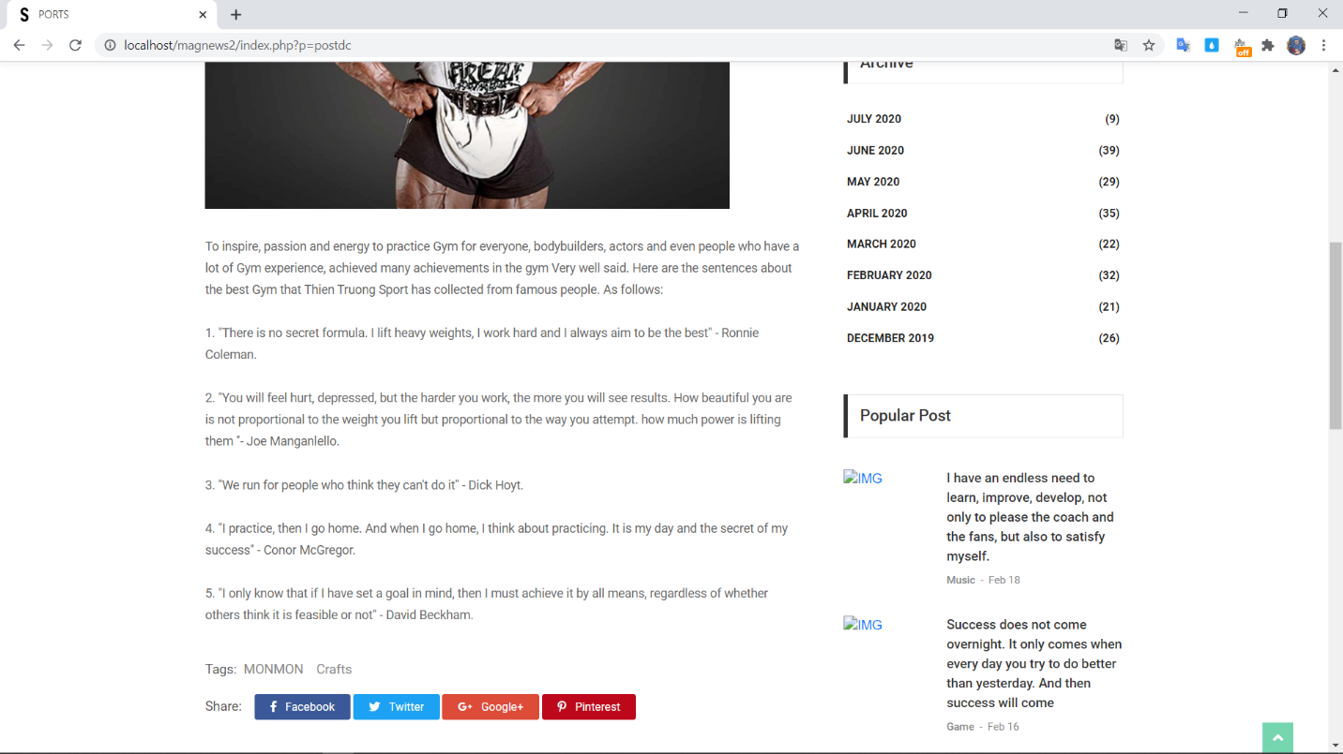
ProFile:

Profile History:

Profile History Detail:

Cart Page:

THANKS FOR WATCHING

